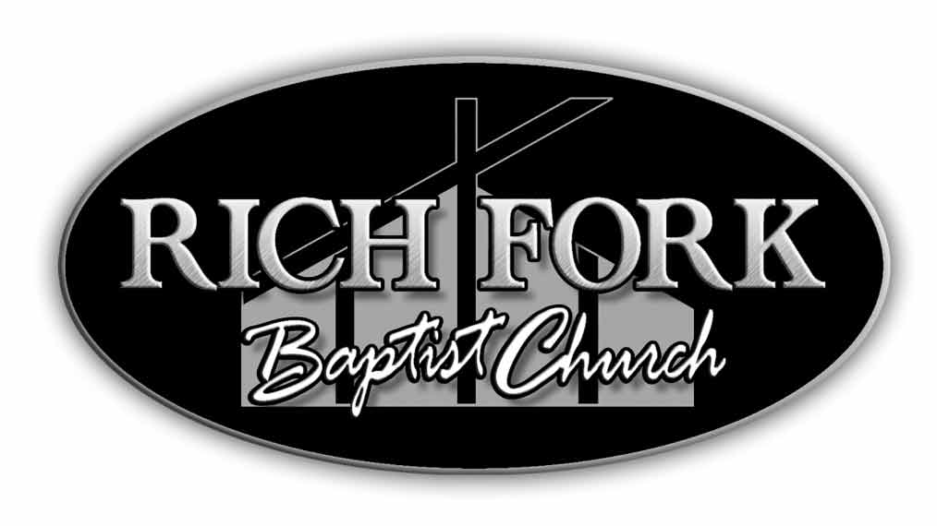
Proposed 2013 Budget
Expected Receipts
Offerings | 1,429,596
Loose Offerings | 20,000
Interest Earned | 2,500
Counseling | 3,000
Rental | 10,000
Other | 500
Total | 1,465,596
Missions Ministry
Missions Trips | 52,761
Cooperative Program | 64,486
Lottie Moon | 5,569
Women on Mission | 586
Annie Armstrong | 2,785
State Missions | 586
Local Missions | 19,053
Liberty Baptist Association | 2,785
Benevolence | 12,604
Independent Missionary Support | 14,656
Total | 175,872
Ministries
Special Needs | 3,500
Senior Adults | 5,000
Youth | 25,000
College & Career | 8,200
Counseling | 15,000
Total | 56,700
Education Ministries
Literature & Supplies | 14,400
Outreach | 9,135
Recreation | 3,800
VBS | 3,200
Children | 8,350
Preschool | 5,200
Music | 20,700
Baptist Women | 400
Total | 65,185
Support Services
Office | 13,448
Office Equipment | 14,894
Church Supplies | 700
Library Media Center | 2,000
Audio Video | 11,000
Flowers | 900
Deacon Supplies | 300
Special Days/Hospitality | 500
Gatekeepers (Security) | 4,000
Audit/Review | 1,500
Total | 49,242
Maintenance
Utilities | 91,000
Insurance | 17,000
Kitchen Supplies | 573
General Repairs Bldg Comm | 20,000
Plumbing/Heating/Cooling | 10,000
Grounds Maintenance | 18,000
Janitorial Supplies | 5,075
Apartment Expenses/Maint | 1,000
Total | 162,648
Personnel
Staff Payroll | 106,114
Pastoral Staff Salaries | 282,484
Pastoral Housing Allowance | 138,319
Payroll Services | 1,800
Health Ins Pastoral/Staff | 167,000
Staff Conferences/Develop | 4,000
Social Security/Medicare | 13,856
Pastor Exp Acct | 1,000
Annuities | 31,866
Milage Reimbursement | 7,985
Christmas Bonus | 10,800
Total | 765,224
Misc | 5,000
Building Program | 155,726
Capital Improvements | 30,000
Total | 190,726
Grand Total | 1,465,596

